**Part 1: Servers**

**Step 1: Access the command line.**

**Step 2: Display the services currently running**

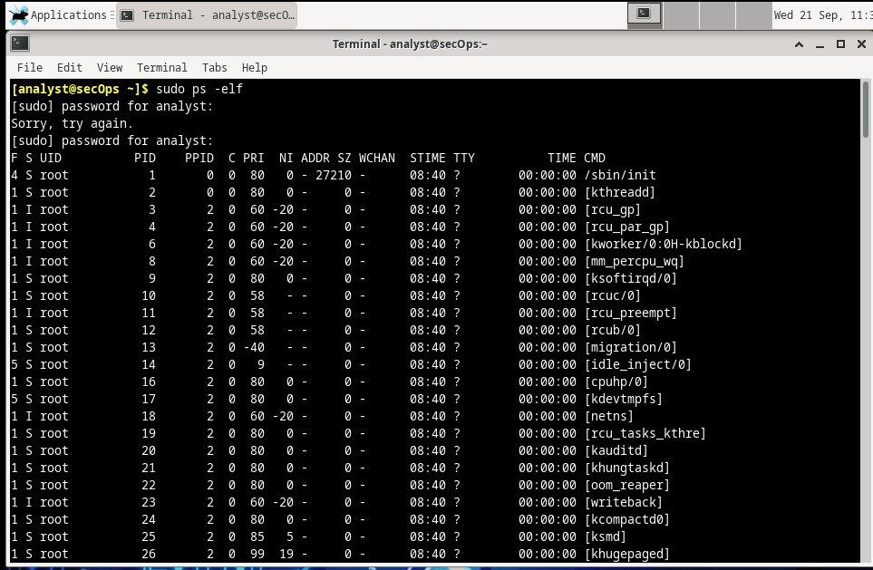

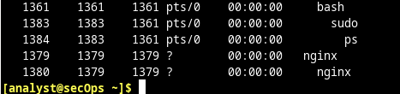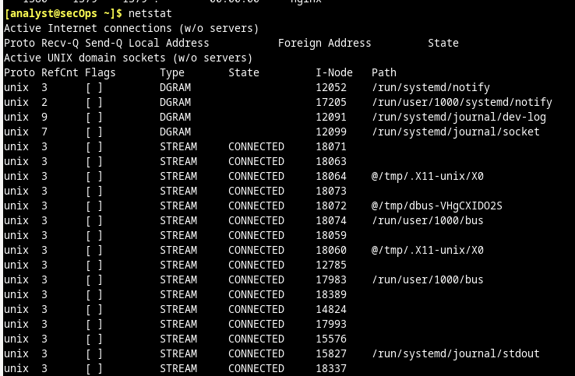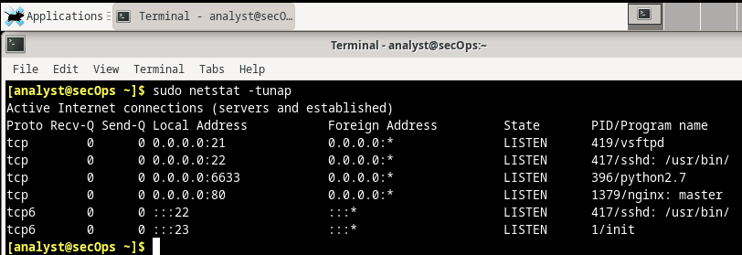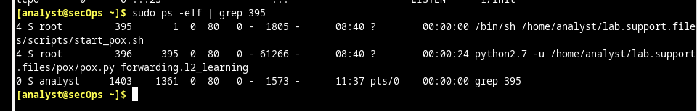**Part 2: Using Telnet to Test TCP Services**

